# Behavioral Diagrams

## C:\Users\TRAINING\AppData\Local\Microsoft\Windows\INetCache\Content.Word\Use Case.jpgHigh Level Use Case Diagram

Figure 2 Behavioral High-Level Use Case Diagram

## Low Level Activity Diagram

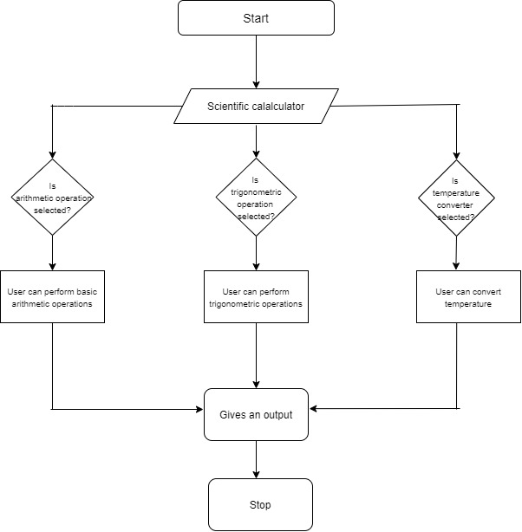

Figure 3 Behavioral Low-Level Activity Diagram

## Low Level Sequence Diagram

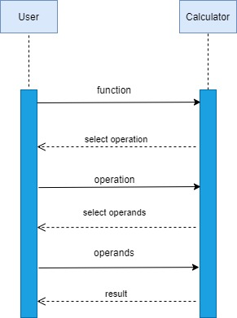

**Figure 4 Behavioral Low-Level Sequence Diagram**